**E-commerce Platform Search Function**

OUTPUT SCREENSHOT

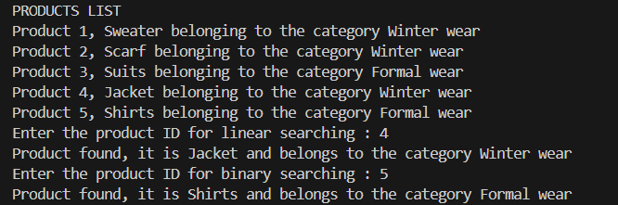

CODE ANALYSIS

There are 3 classes in my code.

* Product class which has a public constructor, private members and public getter and setter methods to define a particular product
* ECommerceSearch class which contains a public method for performing linear search and a public method for performing binary search on the product array. It also contains a public method for displaying the original array
* Demo class which contains the main method and commences the execution of the code.

While the linear search method performs a simple sequential search on the product elements, the binary search method first sorts the products array in ascending order of their product IDs and then performs binary search on it.

INFERENCE

Time complexity of linear search algorithm = O(n)

Time complexity of binary search algorithm = (O log n)

While binary search is more efficient as compared to linear search, the former incurs the requirement of sorting the array. On the other hand, linear search which takes a comparatively longer time has no such former requirement of the array being sorted.